Practical 1: Packet Tracer - Configure Cisco Routers for Syslog, NTP, and SSH Operations

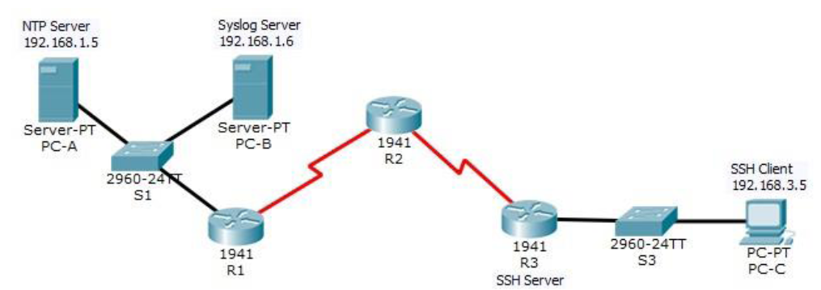
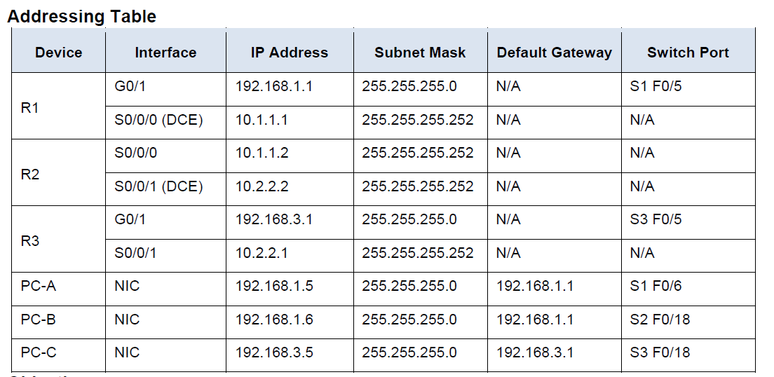
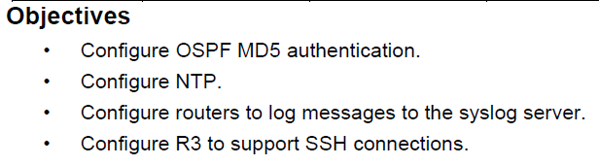
Part 1: Configure OSPF MD5 Authentication
Step 1: Test connectivity. All devices should be able to ping all other IP addresses.
Step 2: Configure OSPF MD5 authentication and MD5 key for all the routers in area 0.
On router 1:
Router ospf 1
area 0 authentication message-digest
interface s0/0/0
ip ospf message-digest-key 1 md5 MD5pa55

On router 2:
Router ospf 1
area 0 authentication message-digest
interface s0/0/0
ip ospf message-digest-key 1 md5 MD5pa55
interface s0/0/1
ip ospf message-digest-key 2 md5 MD5pa55

On router 2:
Router ospf 1
area 0 authentication message-digest
interface s0/0/1
ip ospf message-digest-key 2 md5 MD5pa55

Step 4: Verify configurations.
On all routers run command :
Show ip ospf interface

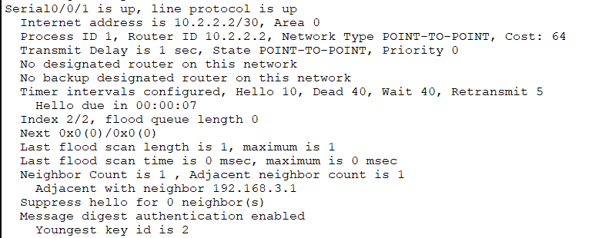

Part 2: Configure NTP (Network time protocol)
synchronize the time of all routers with PC-A (which acts as the NTP server).
Step 1: Enable NTP authentication on PC-A.
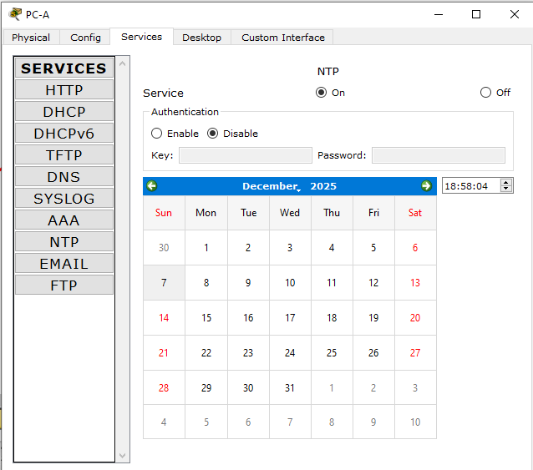

Step 2:Configure all routers as NTP client, configureall router to update clock
ntp server 192.168.1.5
ntp update-calendar
show ntp status
show clock

Step 3: configure NTP authentication on all routers

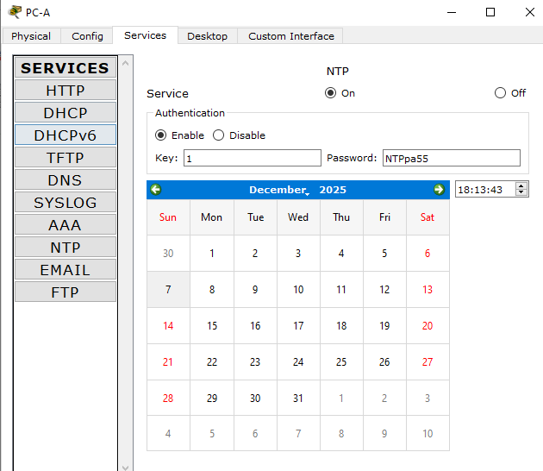

ntp authenticate
ntp trusted-key 1
ntp authentication-key 1 md5 NTPpa55

show running-config

Part 3: Configure Routers to Log Messages to the Syslog (System Logging Protocol) Server
Step 1: Configure the routers to identify the remote host (Syslog Server) that will receive logging messages. Configure routers to timestamp log messages.
logging host 192.168.1.6
service timestamps log datetime msec
Step 2: Verify logging configuration.
show logging
Step 3: Examine logs of the Syslog Server. (Do on any 1 router)
interface GigaEthernet0/0
shutdown
no shutdown
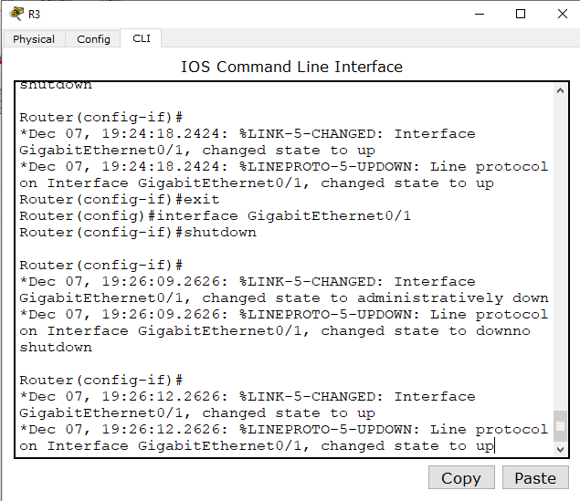
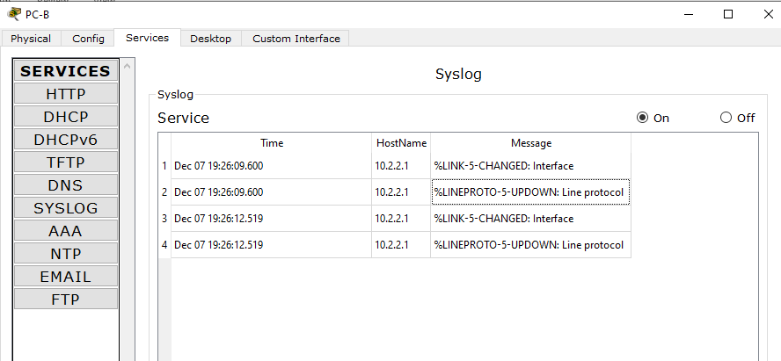

Part 4: Configure R3 to Support SSH Connections
ip domain-name ccnasecurity.com
username SSHadmin privilege 15 secret ciscosshpa55
line vty 0 4
login local
transport input ssh
crypto key zeroize rsa
crypto key generate rsa
show ip ssh
Attempt to connect to R3 via Telnet from PC-C.
